Clinical Analytics Report: Bone Tumor Patient Cohort
1. Project Overview
This clinical dashboard provides a comprehensive analysis of a bone tumor dataset, integrating data from SQL Server, Python-based modeling, and Power BI visualization. The project aims to transform raw patient records into actionable clinical insights by examining demographics, treatment patterns, histological subtypes, anatomical tumor sites, and clinical outcomes.

2. Key Dashboard Findings
Based on the exploratory analysis of the patient cohort, the following key observations were identified:
- Demographic Distribution: The cohort includes both male and female patients, with female patients constituting the larger proportion of the studied group.

- Age Profile: The average patient age is approximately 55 years, indicating that the disease burden in this specific dataset is concentrated in the middle-aged to older adult population.
- Treatment Strategy: Combined therapeutic approaches are more frequently observed than single-modality treatments. Multimodal strategies, such as Radiotherapy + Surgery and Radiotherapy + Surgery + Chemotherapy, appear as dominant clinical pathways.
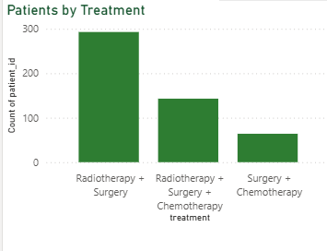
- Clinical Outcomes: The majority of patients are recorded as NED (No Evidence of Disease) at the time of follow-up, though significant subgroups categorized as AWD (Alive With Disease) and D (Death) highlight the complexity of the disease.
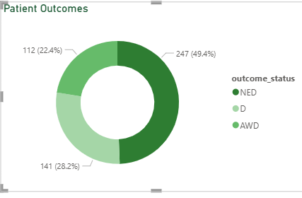
- Anatomical Localization: Tumors are not uniformly distributed; limb-related regions, particularly the thigh and biceps, alongside pelvic/buttock sites, represent the most frequent primary tumor locations.
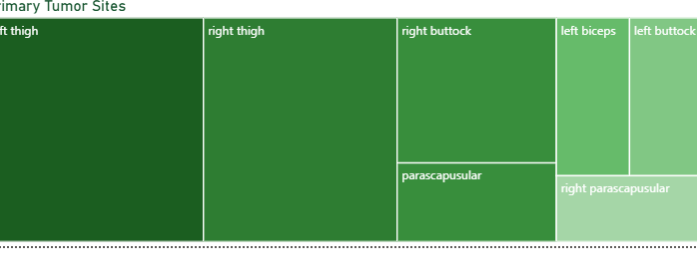
- Histological Patterns: The dataset shows a high concentration of specific sarcoma subtypes, with Leiomyosarcoma and Synovial Sarcoma emerging as the most prevalent histological categories.
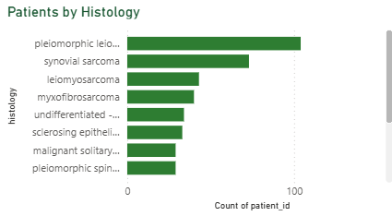
- Subtype Stratification: MSKCC-based categorization provides an effective layer for disease stratification, showing distinct patterns in patient volume and outcome distribution across different tumor types.
- 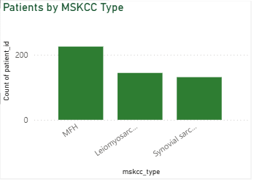

3. Clinical Interpretation
The findings suggest a heterogeneous patient population where treatment planning is highly individualized and typically multimodal. The concentration of cases in specific anatomical sites and histological subtypes indicates that these variables are critical descriptive features for cohort characterization.
The prevalence of combined treatments (Surgery, Radiotherapy, and Chemotherapy) reflects the standard of care for complex bone tumors, where local control and systemic therapy are often coordinated to manage the risk of recurrence and metastasis.

4. Data Quality & Reporting Limitations
To ensure clinical and analytical integrity, the following limitations must be acknowledged:
- Follow-Up Status vs. Survival Analysis: The survival indicators in this dashboard reflect observed follow-up status ratios. They do not constitute a formal Kaplan-Meier survival analysis, as they do not account for time-to-event data, censoring, or specific follow-up durations.
- KPI Validation: Certain metrics, specifically the Survival Rate, should be interpreted as exploratory indicators. Future iterations require the use of DISTINCTCOUNT logic to prevent potential row-level counting errors and ensure metric reliability across all filter contexts.
- Descriptive Nature: This report is descriptive and exploratory. It identifies patterns and correlations within the dataset but does not establish causal relationships between specific treatments and patient outcomes.
- Clinical Context: These findings are cohort-specific. While they provide valuable insights into this dataset, they should not be generalized to the broader population without further clinical validation and external dataset verification.

5. Technical Note for Future Development
For the next phase of development, the following technical improvements are recommended:
- Implement standardized clinical definitions for all outcome measures.
- Transition from row-based counts to patient-level unique identifiers (DISTINCTCOUNT) in all DAX measures.
- Incorporate longitudinal data to enable true survival modeling (Time-to-Event).
- Integrate the Python-based Machine Learning results directly into the Power BI environment for real-time predictive scoring.

6. Conclusion
This Power BI dashboard demonstrates the successful transformation of structured clinical data into an interactive decision-support environment. By combining SQL Server for data orchestration, Python for analytical modeling, and Power BI for visual storytelling, the project provides a robust foundation for understanding the bone tumor patient landscape.
While the current implementation is intended for exploratory analytics and educational purposes, the overall architecture is designed to be scalable. It offers a clear pathway for integrating advanced predictive modeling and larger clinical datasets to support data-driven insights in musculoskeletal oncology.

7. Medical Disclaimer
This dashboard and report are intended for educational, analytical, and portfolio purposes only. They do not provide medical advice, diagnostic guidance, or treatment recommendations. All clinical patterns identified should be validated by medical professionals and formal statistical methodologies before being applied in clinical settings.

